How To: Create an account

- From www.philanthropycolorado.org homepage, navigate to the top right of the page and click ‘Register’
- Fill in your account details
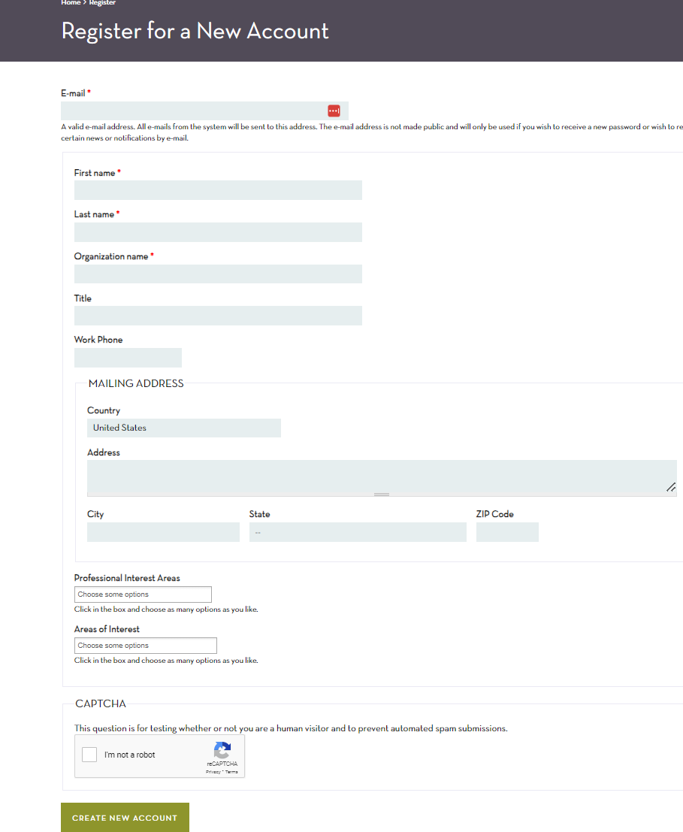
- Click ‘Create Account’
- You will receive an email about creating your account. An admin on our end of the organization with activate your account
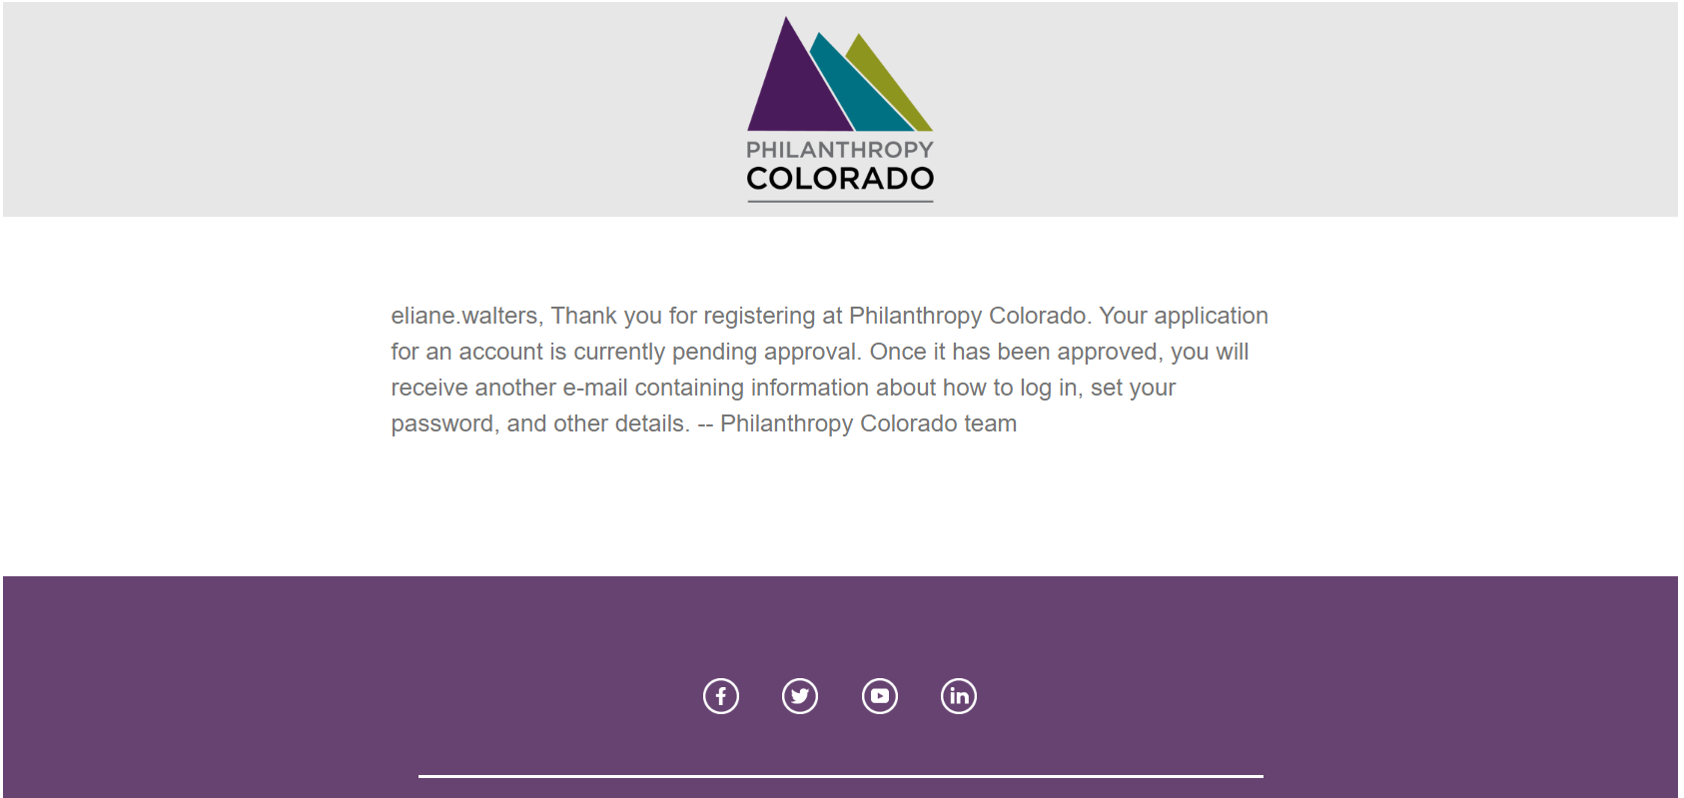
- Once your account is activated you will receive another email to create your password. Click the link to reset your password.
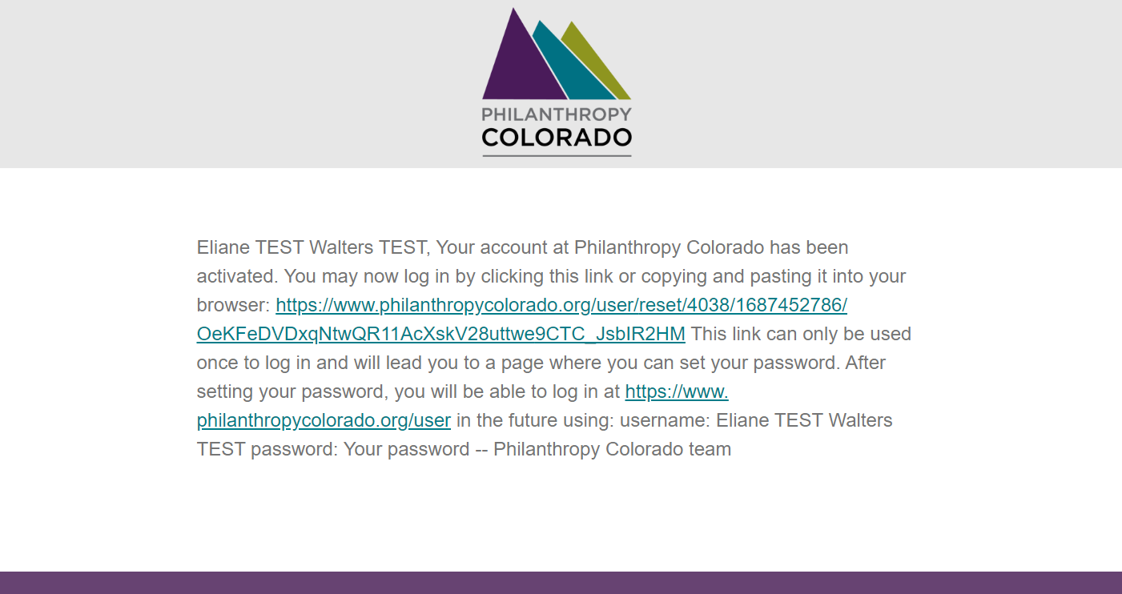
- Once redirected click ‘Log in’
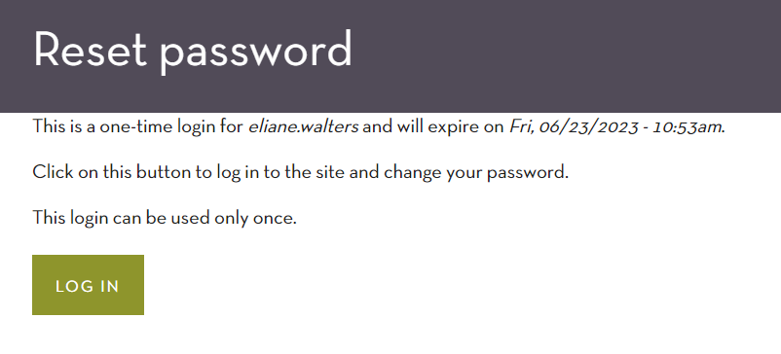
- From here choose a password you would like to use for your log in credentials. Scroll down and click ‘Save’
- Once your new password is set you will be able to navigate the website
- If you have any question or issues with this process reach out to Eliane Walters
View the Program calendar to register for events
Read our Giving Voice Blog
Update your account or view your details by clicking ‘My Account’

