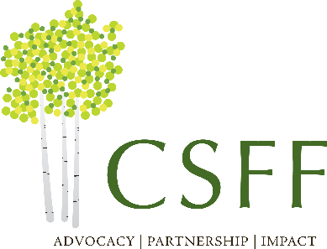

PROGRAM OFFICER

The Craig-Scheckman Family Foundation (CSFF) is seeking an experienced Program Officer to help build relationships with our funding partners and community leaders in order to improve pathways towards equitable access to health and quality of life for individuals in Northwest Colorado. This is an exciting opportunity to join a devoted and passionate team of staff and board in guiding the future growth and impact of the foundation.

CSFF is a private family foundation located in Steamboat Springs, Colorado. The foundation was founded in 2005 and looks to increase its depth and breadth of funding impact over the next decade. We believe creating genuine systems change at the local level can only be accomplished through the building and cultivating of trusted and respected partnerships.

The ideal candidate will utilize their experience, knowledge, and thirst for learning to fulfill the following responsibilities:

- Develop relationships with our funding partners that foster trust and respect
- Evaluate funding proposals and make recommendations with staff to the Board of Directors
- Monitor impact of funding commitments and partner organizations through data and evaluation
- Review and analyze organizational budgets and provide guidance for sustainability
- Identify additional areas of support to assist organizations in achieving their optimal potential
- Seek opportunities for enhanced advocacy, collaboration, and governance for organizations
- Work closely with community organizations and local leaders to identify local needs
- Develop relationships with other grant makers and coordinate funding efforts, if possible
- Remain current on emerging trends in philanthropy and the nonprofit community.

This position requires a breadth of knowledge rather than depth in one area of interest. Most important is the understating of effective funding strategies and familiarity with approaches to measure the impact within the communities we serve. Candidates should possess the following qualifications:

- A clear commitment to the mission and vision of CSFF
- Minimum of five years Program Officer or grantmaking experience
- Ability to analyze and synthesize quantitative and qualitative data
- Willingness to ask difficult questions and challenge assumptions
- Knowledge of rural communities and best practices for nonprofit organizations
- Openness and flexibility to diverse ideas and an inclination to learn new concepts
- Creative problem-solver with natural intellectual curiosity.

CSFF offers a full and generous benefits package including health insurance, retirement program, liberal vacation, and a quality work environment. The starting salary range for this position is $80K - $95K per year. Interested candidates should send a cover letter and resume in a single pdf to mark@csff.org.

The Craig-Scheckman Family Foundation is an Equal Opportunity Employer and welcomes a diversity of perspectives and experiences. We invite qualified candidates from all backgrounds to apply.

